Early Permanence Information for Contact/Family Time Workers

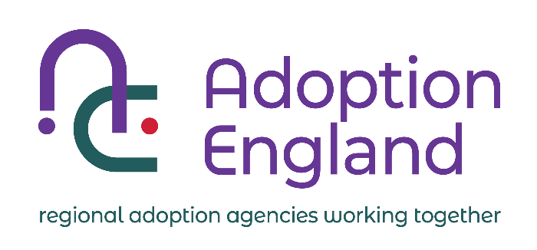

**Why have you been given this leaflet?**

You have been given this leaflet because you are currently, or may in the future be, supervising contact/family time for a child placed in an Early Permanence (EP) arrangement.  You should also have been given the leaflet ‘Information for Parents: Early Permanence’ which gives more detailed information about EP.  In many ways arrangements for EP contacts are the same as for children in traditional foster placements, however there are some key differences.  Contact/family time workers are important professionals in EP placements, often having regular contact with the child, family and EP carers.

**Handover arrangements for contact**

Unless it is not safe to do so, EP carers are likely to come to the start and end of contact/family time sessions.  These arrangements are made to minimise the number of adults that the child has to interact with.  They also give the opportunity for the family to meet the EP carers, in recognition that these carers may also in the future be the child/ren’s adoptive parents. These interactions may bring the family some reassurance if the child/ren goes on to be adopted, and will give the child the opportunity to hear first-hand accounts about their family if they are adopted.

However, these interactions can also generate a lot of difficult emotions for both the family and the EP carers.  Therefore contact/family time sessions are not the best time for parents or carers to be sharing important or detailed information about the child/ren, or trying to resolve any concerns that the family may have about the EP carers.  As with all sessions, it may be necessary for you to direct one or more of the parties to the social worker or to your agency’s complaints process.

**Communication between family and EP carers**

The EP carers will usually be expected to keep a communication book of some sort (depending on the needs of the child / family) that passes information to the family about how the child has been since the last contact/family time, any important milestones, any relevant questions etc.  The child’s family are also able to write in the book to share information and to make appropriate requests.  If there is an area of disagreement or upset, this should be passed to the social worker to resolve outside of the session and away from the child/ren.

**Confidentiality**

Although the EP carers will potentially adopt the child/ren, they only become adopters if the Court grant a placement order and they are formally matched.  This may never happen as the outcome of Court may be that the child/ren returns to a parent or family member.  EP carers **do not** have parental responsibility and **are not** part of the Court proceedings.  Therefore the only information they should be given about the contact/family time session is that which is relevant to caring for the child, e.g. feeding, nappy changes etc.

EP carers need professionals to keep their details confidential from family members.  The family should not know where the EP carers live or their last names.  These details need to be safeguarded not just because of any immediate risks, but because of future risks to the stability of any adoptive placement.  Ensure the child/ren’s social worker gives you clear details regarding confidentiality arrangements on each individual case.

**The importance of sensitivity**

Although EP carers are carrying out the role of a foster carer, if the courts make a placement order they will adopt the child/ren they are caring for.  EP carers often refer to Early Permanence as like a “rollercoaster,” one minute things look like the child could be positively returned to their family, the next minute it looks like the child may need a plan for adoption.  Therefore, simple comments like “contact went well today” may generate a lot of emotion or uncertainty for EP carers.

EP carers want what is best for the child, and understand that this is with their family if they can provide ‘good enough’ care.  Therefore they are balancing that they may only ever be a foster carer for the child/ren, whilst bonding with the child/ren and preparing themselves that the child/ren could be with them permanently.  This is very different to a traditional foster carer who has made a clear decision to provide children with care until they can either return to their family or move to a longer term permanence option such as long term foster care or adoption.

**The importance of avoiding over-reassurance**

Parents can and do make huge transformations during Court proceedings, relatives that are willing and able to care for the child/ren do come forward unexpectedly and circumstances do change.  EP carers manage these uncertainties, so that the child does not have to.  Whilst they have been assessed as able to manage this uncertainty, it is really important for professionals not to underestimate the emotional challenge, or for professionals to be tempted to offer reassurances that are not evidence based or factual.

EP carers, where a child has returned to their family, and those that have gone on to adopt the child placed with them through EP, both say that it is really unhelpful when professionals offer over-reassurance, even when well meaning.  Stick to factual information only.  It is really important to always remain mindful that only the Court can decide whether a child will return to their family or not.

**Things to remember about early permanence:**

* If a child returns to their parents or wider family the EP placement did not ‘fail.’ – children should always be with their birth or extended family if they can be provided with good enough care.
* EP is in the best interests of a child when there is a possible plan of adoption being considered – the adults hold the uncertainty so that the child doesn’t have to.
* EP carers are assessed and supported to manage uncertainties.  Many people struggle to imagine coping with the EP carer role, but evidence shows it can be done well, greatly benefiting children.  EP carers just want professionals to remain mindful of the uncertainties that they are managing on a daily basis.

**For further information about Early Permanence:**

[**https://www.first4adoption.org.uk/who-can-adopt-a-child/early-permanence/**](https://www.first4adoption.org.uk/who-can-adopt-a-child/early-permanence/)