Early Permanence Information for Parents

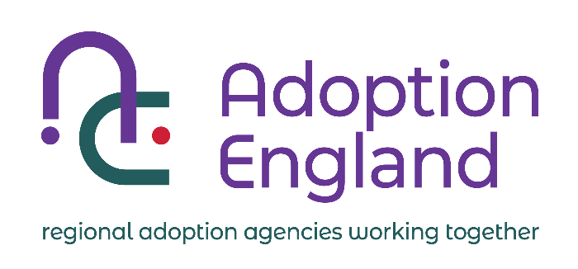

**Why have you been given this leaflet?**

You have been given this leaflet because your Local Authority are currently considering whether you are able to provide ‘good enough’ care to your child/ren. ‘Good enough’ is a term used in Court and basically means you can adequately meet all the needs your child has.

The Local Authority will also be worried that you may not be able to make the changes your child/ren need you to make fast enough, and to maintain the changes required to minimise concerns and risks to your child/ren for them not to suffer ‘significant harm’. Because of these concerns, the Local Authority are currently considering whether it would be best for your child/ren to be adopted. This is likely to be very difficult for you to think about, therefore sources of further information and support are listed at the end of this leaflet.

**What is Early Permanence?**

Early Permanence is a way of providing children with the security of a safe, permanent home, as soon as possible, should they need it. Having a permanent home offers children security and stability that can benefit their physical, social and emotional development throughout their lives.

Staying in foster care is not always good for young children, especially if they have to move to more than one foster carer whilst the Court are making decisions about your child/ren’s future. Your child/ren may develop a strong attachment to their foster carer(s), but then have to move again to an adoptive family if the Court decides that your child/ren cannot return to your care.

**How does Early Permanence work?**

Early Permanence Carers are carers who have been approved to adopt, but who have also been approved as foster carers. Your child/ren would be placed with these carers in either a ‘Concurrency’ or a ‘Foster to Adopt’ placement. Both these types of Early Permanence placements mean that your child/ren will be cared for under fostering regulations, until the Court decides whether your child/ren should return to your care or to a family member. If the Court orders that the children return to your care or to a family member, these early permanence carers will support the child/ren’s return and they will only ever have been foster carers. However, if the Court grants a ‘placement order’ (which means that the court has decided that your child/ren should be adopted), then these same carers can go on to adopt your child/ren. This means that your child/ren will not have to go through a further change in carers, avoiding disruption and giving them stability as quickly as possible.

**Does Early Permanence affect the chances of my child/ren remaining in or returning to my care?**

No. If the Court finds you are able to provide ‘good enough’ care to your child or children, in the timescales that the child/ren needs, they will return to you. If the Court decide you cannot safely care for your child/ren, they would then consider if any family members can provide ‘good enough’ care. If they can, your child/ren will return to their wider family. This is exactly the same as if the children were with traditional foster carers or a family member. It is not a competition between you as parents and the EP carers about who can provide the best care.

**Can I meet the Early Permanence carers?**

You are often able to meet the Early Permanence carer(s) if you want to, and you may see them at contact sessions. However, safety concerns for you, your child/ren and the carers will come first, so this will be decided on a case-by-case basis. It is important for you to remember that the early permanence carers are not part of the Court proceedings or decision making and will only be told what they need to know in order to look after the child/ren. Your child/ren is likely to benefit from you giving them positive messages about the carer(s), even though it may be very emotionally hard for you to do so. Many services are open to arranging meetings in the future if it feels too difficult for you to manage such a meeting at the end of court proceedings.

You may find the idea of meeting the person(s) who may go on to adopt your child/ren extremely hard. However, such meetings mean that children who go on to be adopted will have first-hand stories about their biological parents from their adopted parents.

**What should I do next?**

* Share this leaflet with the people who are important to you (family/friends/professionals) and talk it through together.
* Work openly and honestly with the Local Authority and be honest with yourself.
* Tell the Local Authority immediately if there is anyone in your family or friendship network who may be able to care for your child/ren so that they can be assessed as carers.
* Get advice about how to talk to your child/ren about the Early Permanence Carers – however painful the situation is for you, your child/ren need your permission to feel safe, secure and happy with the carer(s) whilst the Court are deciding what is best for the future.

**For further information / support:**

You are bound to be worried and upset please do ask for support. You can get help or advice from:

* Your child’s social worker
* Your child’s court appointed Guardian (If court proceedings have begun)
* Your solicitor or legal representative
* [Family Rights Group](https://frg.org.uk/get-help-and-advice/who/parents-to-be/#:~:text=Contacts%20us%20%E2%80%93%20call%20Family%20Rights,3%20pm%20excluding%20bank%20holidays)) 0808 801 0366
* The Local Authority in which you live may be able to direct you to local independent support for families where adoption is being discussed, or in the event that adoption takes place.
* Samaritans 116 123