Early Permanence Information for Parents

**This leaflet is provided for parents with literacy or learning needs.**

**Your child’s social worker can go through this leaflet with you.**

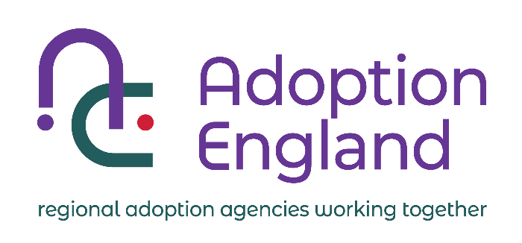

Children’s Services have said that your child can’t live with you for now. The court is deciding what is best for your child.

We understand that this is a difficult and upsetting time for you. It is important that you understand what is happening.  You will need people to explain things and lots of support.

All children want to know about their parents, even if they do not live with them.

Children’s Services want what is best for your child. While the court process is going on and your child can’t live with you, they plan for your child to be cared for by special foster carers called early permanence carers.

What is special about early permanence carers is that they will care for your child while the court decides what needs to happen next.

If the court thinks your child should return to live with you or another member of your family, these foster carers will help that to happen.

If the court decides that your child cannot live with you and needs to be adopted, these foster carers can go on to adopt your child.  This is good for children as this means they are already in a home they can stay in. This stops them having another unsettling move.

You can choose who you show this leaflet to. But if there is someone who you trust it might be helpful to talk this information through with someone.

If you have any questions, you can ask your child’s social worker.

**Organisations and people who can help support you:**

* Your child’s Social Worker
* Your solicitor
* Your own social worker or support worker if you have one
* [Family Rights Group](https://frg.org.uk/get-help-and-advice/who/parents-to-be/#:~:text=Contacts%20us%20%E2%80%93%20call%20Family%20Rights,3%20pm%20excluding%20bank%20holidays)) 0808 801 0366
* Samaritans 116 123