Early Permanence Information for people considering relinquishing a child (also known as Consensual Adoption)

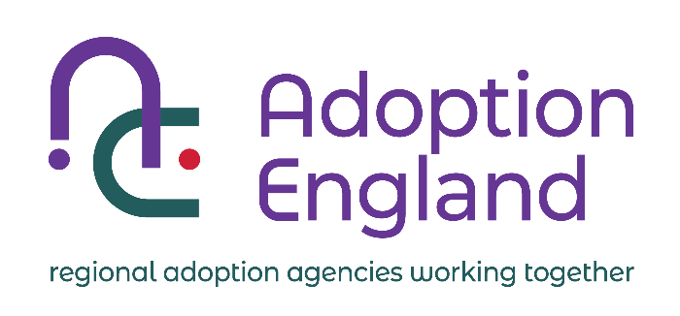

If you are feeling unable to care for your child, for whatever reason, and are considering asking the Local Authority to find an adoptive home for them, this is a very difficult, and upsetting position to be in. You may be feeling scared, confused and alone and are likely to need time and information to help you think through your options.

**Why have you been given this leaflet?**

You have been given this leaflet because you have informed your Local Authority that you are considering, or have decided to, ‘relinquish’ a child.  ‘Relinquish’ is an official term for the process of asking for a child to be cared for by the Local Authority, with the intention of wanting the child to be adopted as soon as legally possible.

This leaflet is to help you understand about Early Permanence, not to help you make the decision about whether or not to relinquish the child.  Sources of further information / support are listed at the end of this leaflet.

Because you are thinking about relinquishment, you may have decided not to think of the child as ‘your’ child, or you may be very clear that the child is ‘your’ child but would be best cared for by someone else.  Both of these options are completely fine and not unusual.  For this leaflet ‘a’ and ‘the’ are used in reference to children.  You are able to decide how you want the child to be referred to in your presence, but legally you will be the child’s parent.

**What is Early Permanence?**

Early Permanence is a way of providing children who need it with the security of a safe permanent home from the earliest point.  Having a permanent home offers children security and stability that can benefit their physical, social and emotional development throughout their lives.

Staying in temporary foster care, even for a short time, is not always good for young children.  This is especially true if they have to move to more than one foster carer whilst the official relinquishment process is underway.  The child may begin to develop a strong attachment to their foster carer(s), but then have to move again to an adoptive family once the child is legally able to be placed for adoption.

**How does Early Permanence work?**

Early Permanence Carers are carers who have been approved to adopt, but who have also been approved as foster carers.  Early Permanence placements mean that a child will receive foster care as a looked after child (a child in the care of the Local Authority), until the child is legally able to be adopted.  Early Permanence placements are designed to stop the child having to move from foster carers to adopters, thereby avoiding disruption and giving the child stability as quickly as possible.

Early permanence does not affect your right to seek the return of your child before consent has been given (formal consent cannot be given until the child is as least 6 weeks old). Even when formal consent has been given you can withdraw your consent to the adoption at any stage prior to the prospective adopters issuing an adoption application in relation to the child.  If you decide not to go ahead with relinquishment, the child will remain in or return to your care, or the care of a family member, if safe and appropriate. EP carers are committed to children being reunited if this is what is decided and the carers will support the child’s return to you.  However, if you do decide that you wish your child to be

adopted then these carers are ready to offer your child the security of adoption without them having to face another move.

Early permanence carers are fully assessed and thoroughly prepared. They will be carefully matched with your child based on the information we know about them and your child. For this reason, it is important that you share any information that will help them offer the very best care they can to your child, e.g. any health issues that may be significant to your child.

If the Local Authority have concerns about whether or not you can provide ‘good enough’ care (this is a term used in Court) to the child, they will seek legal advice and you will be entitled to free legal advice.  This is exactly the same as if the child were with traditional foster carers or a family member.

**Can I meet the Early Permanence carers?**

 You are usually able to meet the Early Permanence carer(s) if you want to, and you may see them at contact sessions if you decide to have contact with the child.  However, any safety concerns for you, the child and the carers will come first.  If this feels too hard for you now, it may be possible in the future so talk to the Local Authority if this is something you might be open to in the years ahead.

**What should I do next?**

* Share this leaflet with the people who are important to you (family/friend/professionals) and talk it through together.
* Work openly and honestly with the Local Authority and be honest with yourself about any worries or doubts you may have.
* Never be worried to say if you change your mind – this is a big decision.
* Do not feel pressured into changing your mind – only you can make this decision.
* Tell the local Authority immediately if there is anyone in your family or friend’s network who you want to care for the child so that they can be assessed as carers.

**For further information/support:**

* The child’s social worker
* Your GP and/or midwife
* A solicitor or legal representative
* The Local Authority in which you live will be able to direct you to where independent support for families can be accessed when adoption is being discussed, or in the event that adoption takes place.