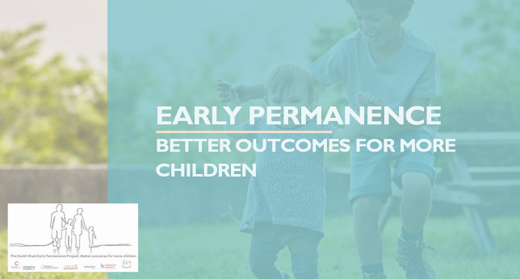

**North West EP Project For Older Children**

**Cathy Sowden and Kayleigh Starkie**

**Adoption North West Website**

**Handbook for EP Carers**

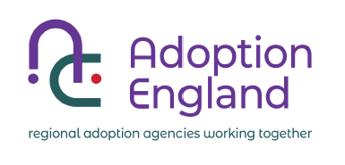

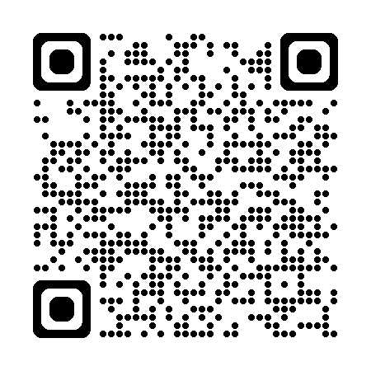

**Matching Videos**

**What do you like about the resource? When would you use it?**

**Resource 1 – Moving From My Family into My Foster family**

**What would you change about this resource?**

**Any other comments?**

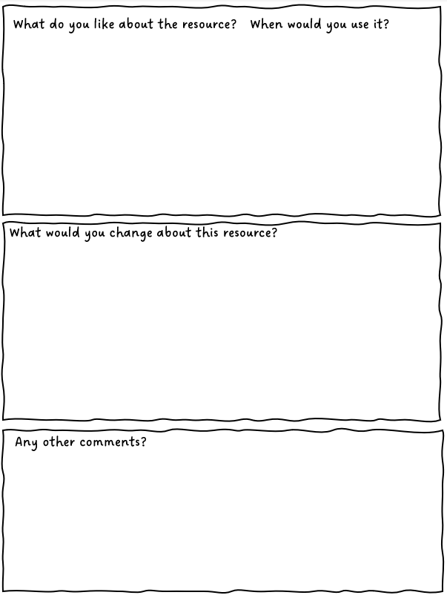

**Resource 2 – “Side by Side”**